Installing UCF Stormwater Academy Certificates
By Colin Miller, P.E.

Background
The certificates provide a security mechanism for documents, spreadsheets, and programs. It provides anti-tampering protection by making unauthorized changes obvious. Most modern operating systems (Windows) and programs (Excel¹) provide simple to use certificate authentication (that is, nearly transparent).

Summary
Installation of certificates is a one-time operation which will provide anti-tampering protection for all certificate signed documents, spreadsheets, and programs. The UCF Stormwater Academy Certificates must be installed on each computer which the certificates will be confirmed.
Installation of certificates are not necessary to use UCF Stormwater Academy documents, spreadsheets, and programs; only to confirm they do not contain unauthorized modifications.
Installation involves two certificates installed in two stores (see below for detailed instructions).
- Install UCF Stormwater Academy Certificate Authority in Trusted Root Certification Authorities
(UCF_SW_ACAD_CA_PUB_KEY.p7b, sha1 0DB52FEF942409E83257925808C416B024EA6301)
- Install UCF Stormwater Academy Code Signing Certificate in Trusted Publishers
(UCF_SW_ACAD_CODE_PUB_KEY.p7b, sha1 C262626070A528ECD1AED853432AFA9A83C8F960)

Step-by-Step Instructions
The following instructions are for Windows based computers (that is, Windows 7, 8.x, and 10). The entire process should take about one (1) to five (5) minutes. Click is left mouse button, Right-Click is right mouse button and Select is a Click on a specific option.
Install UCF Stormwater Academy Certificate Authority
(UCF_SW_ACAD_CA_PUB_KEY.p7b, sha1 0DB52FEF942409E83257925808C416B024EA6301)
- Download UCF_SW_ACAD_CA_PUB_KEY.p7b from https://stormwater.ucf.edu/computer-programs/
- Locate downloaded file (UCF_SW_ACAD_CA_PUB_KEY.p7b) in File Explorer, Right-Click on file, Select “Install Certificate”
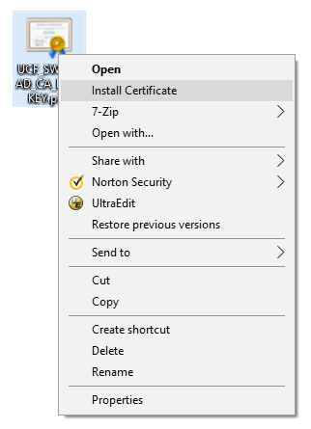
- Import Certificate, Click “Next”
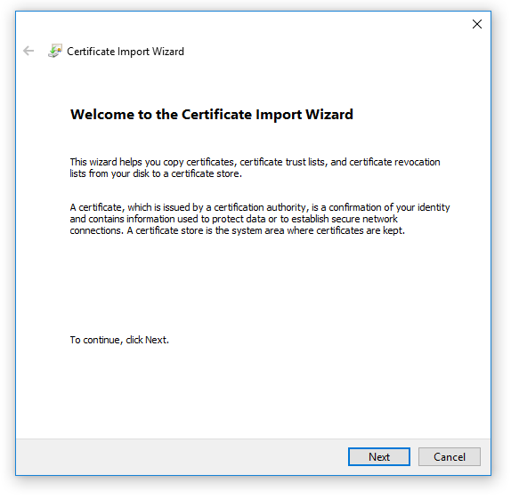
- Define Location, Select “Place all certificates in the following store” and Click “Browse”
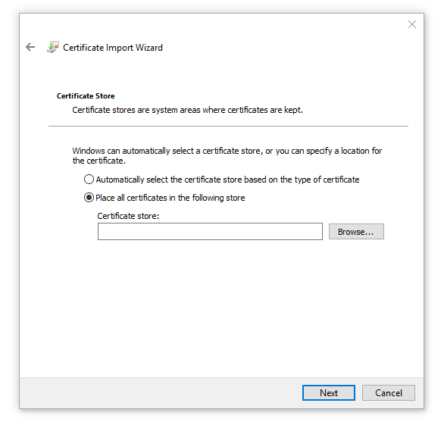
- Select Location, Select “Trusted Root Certification Authorities” and Click “OK”
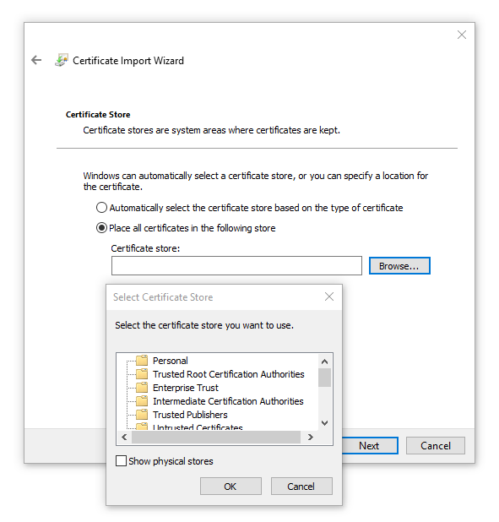
- Certificate Store, Click “Next”
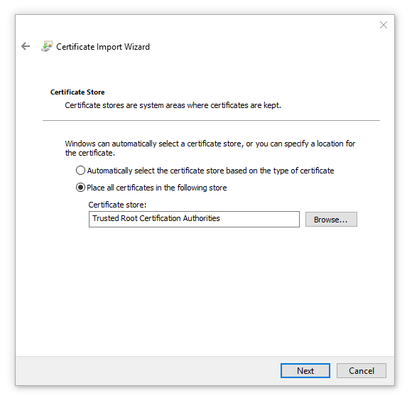
- Security Warning, Confirm Thumbprint (sha1) is “FD39CB5F 6C6AA845 748AB71F 9EA315EC 59170183” (spaces can be ignored), Click “Yes”; If Thumbprint displayed does not match the one above Click “No” and contact UCF Stormwater Academy
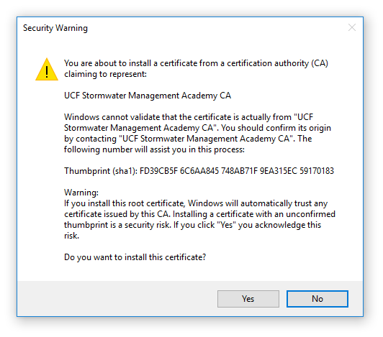
- Installation Confirmation, Click “OK”
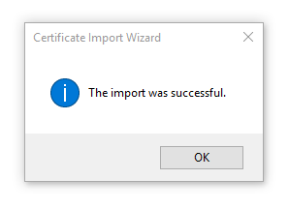
UCF Stormwater Academy Certificate Authority Public Key has been installed.

Install UCF Stormwater Academy Code Signing Certificate
(UCF_SW_ACAD_CODE_PUB_KEY.p7b, sha1 C262626070A528ECD1AED853432AFA9A83C8F960)

- Download UCF_SW_ACAD_CODE_PUB_KEY.p7b from https://stormwater.ucf.edu/computer-programs/
- Locate downloaded file (UCF_SW_ACAD_CODE_PUB_KEY.p7b) in File Explorer, Right-Click on file, Select “Install Certificate”
- Import Certificate, Click “Next”
- Define Location, Select “Place all certificates in the following store” and Click “Browse”
- Select Location, Select “Trusted Publishers” and Click “OK”
- Certificate Store, Click “Next”
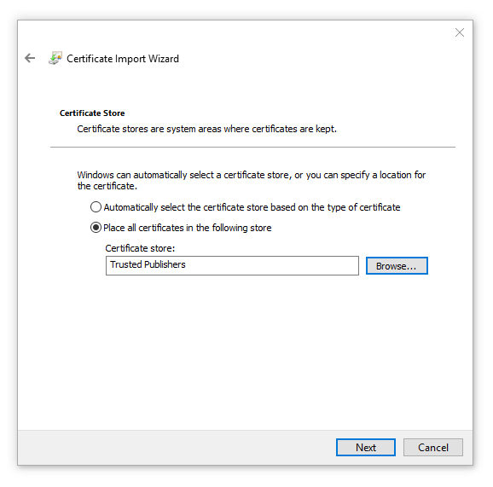
- Installation Confirmation, Click “OK”
UCF Stormwater Academy Code Signing Public Key has been installed.

Windows and Excel are registered trademarks of Microsoft, there use is not an endorsement

